**ASSIGNMENT 4**

|  |  |
| --- | --- |
| Date | 13 October 2022 |
| Team ID | PNT2022TMID52815 |
| Project Name | Project -Smart Waste Management System For Metropolitan Cities |

Write code and connections in wokwi for the ultrasonic sensor. Whenever the distance is less than 100cms send an "alert" to the IBM cloud and display in the device recent events. Upload document with wokwi share link and images of IBM cloud.

**Wowki Link**: https://wokwi.com/projects/348409044347650644

# Source Code:

# #include <WiFi.h>//library for wifi

# #include <WiFiClient.h>

# #include <PubSubClient.h>//library for MQtt

# #include <ArduinoJson.h>

# // creating the instance by passing pin and typr of dht connected

# float distance;

# #define sound_speed 0.034

# int trigpin=18;

# int echopin=19;

# int led=5;

# int LED=9;

# long duration;

# String message;// creating the instance by passing pin and typr of dht connected

# void callback(char* subscribetopic, byte* payload, unsigned int payloadLength);

# //-------credentials of IBM Accounts------

# #define ORG "gw0bk3"//IBM ORGANITION ID

# #define DEVICE_TYPE "Smart_waste_management_system"//Device type mentioned in ibm watson IOT Platform

# #define DEVICE_ID "1904"//Device ID mentioned in ibm watson IOT Platform

# #define TOKEN "123456789"//Token

# String data3;

# float h, t;

# //-------- Customise the above values --------

# char server[] = ORG ".messaging.internetofthings.ibmcloud.com";// Server Name

# char publishTopic[] = "iot-2/evt/Data/fmt/json";// topic name and type of event perform and format in which data to be send

# char subscribetopic[] = "iot-2/cmd/command/fmt/String";// cmd  REPRESENT command type AND COMMAND IS TEST OF FORMAT STRING

# char authMethod[] = "use-token-auth";// authentication method

# char token[] = TOKEN;

# char clientId[] = "d:" ORG ":" DEVICE_TYPE ":" DEVICE_ID;//client id

# //-----------------------------------------

# WiFiClient wifiClient; // creating the instance for wificlient

# PubSubClient client(server, 1883, callback ,wifiClient); //calling the predefined client id by passing parameter like server id,portand wificredential

# void setup()// configureing the ESP32

# {

# Serial.begin(115200);

# pinMode(trigpin,OUTPUT);

# pinMode(echopin,INPUT);

# pinMode(led,OUTPUT);

# delay(10);

# Serial.println();

# wificonnect();

# mqttconnect();

# }

# void loop()// Recursive Function

# {

# digitalWrite(trigpin,LOW);

# digitalWrite(trigpin,HIGH);

# delay(1000);

# digitalWrite(trigpin,LOW);

# duration=pulseIn(echopin,HIGH);

# distance=duration*sound_speed/2;

# Serial.println("distance"+String(distance)+"cm");

# if(distance<100)

# {

# message="Alert";

# digitalWrite(led,HIGH);

# } else

# {

# message="No problem";

# digitalWrite(led,LOW);

# }

# delay(1000);

# PublishData(distance,message);

# // if (!client.loop()) {

# //   mqttconnect();

# // }

# }

# /*.....................................retrieving to Cloud...............................*/

# void PublishData(float d, String a) {

# mqttconnect();//function call for connecting to ibm

# /*

# creating the String in in form JSon to update the data to ibm cloud

# */

# DynamicJsonDocument doc(1024);

# String payload;

# doc["Distance: "]=d;

# doc["Message: "]=a;

# serializeJson(doc, payload);

# 

# Serial.print("Sending payload: ");

# Serial.println(payload);

# 

# if (client.publish(publishTopic, (char*) payload.c_str())) {

# Serial.println("Publish ok");// if it sucessfully upload data on the cloud then it will print publish ok in Serial monitor or else it will print publish failed

# } else {

# Serial.println("Publish failed");

# }

# 

# }

# void mqttconnect() {

# if (!client.connected()) {

# Serial.print("Reconnecting client to ");

# Serial.println(server);

# while (!!!client.connect(clientId, authMethod, token)) {

# Serial.print(".");

# delay(500);

# }

# 

# initManagedDevice();

# Serial.println();

# }

# }

# void wificonnect() //function defination for wificonnect

# {

# Serial.println();

# Serial.print("Connecting to ");

# WiFi.begin("Wokwi-GUEST", "", 6);//passing the wifi credentials to establish the connection

# while (WiFi.status() != WL_CONNECTED) {

# delay(500);

# Serial.print(".");

# }

# Serial.println("");

# Serial.println("WiFi connected");

# Serial.println("IP address: ");

# Serial.println(WiFi.localIP());

# }

# void initManagedDevice() {

# if (client.subscribe(subscribetopic)) {

# Serial.println((subscribetopic));

# Serial.println("subscribe to cmd OK");

# } else {

# Serial.println("subscribe to cmd FAILED");

# }

# }

# void callback(char* subscribetopic, byte* payload, unsigned int payloadLength)

# {

# 

# Serial.print("callback invoked for topic: ");

# Serial.println(subscribetopic);

# for (int i = 0; i < payloadLength; i++) {

# //Serial.print((char)payload[i]);

# data3 += (char)payload[i];

# }

# Serial.println("data: "+ data3);

# if(data3=="lighton")

# {

# Serial.println(data3);

# digitalWrite(LED,HIGH);

# }

# else

# {

# Serial.println(data3);

# digitalWrite(LED,LOW);

# }

# data3="";

# }

# OUTPUT:

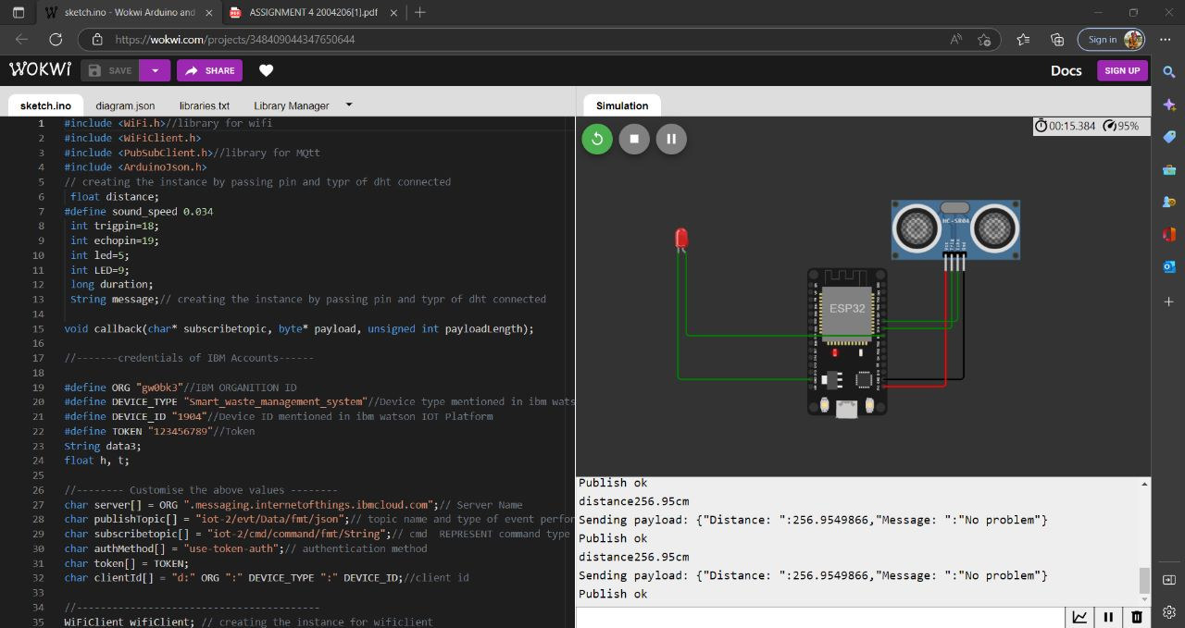

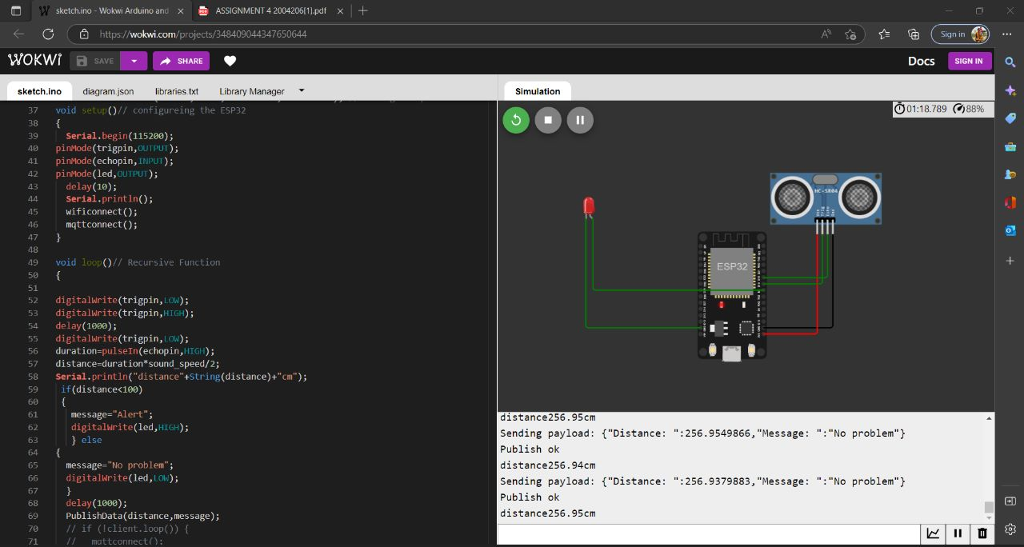

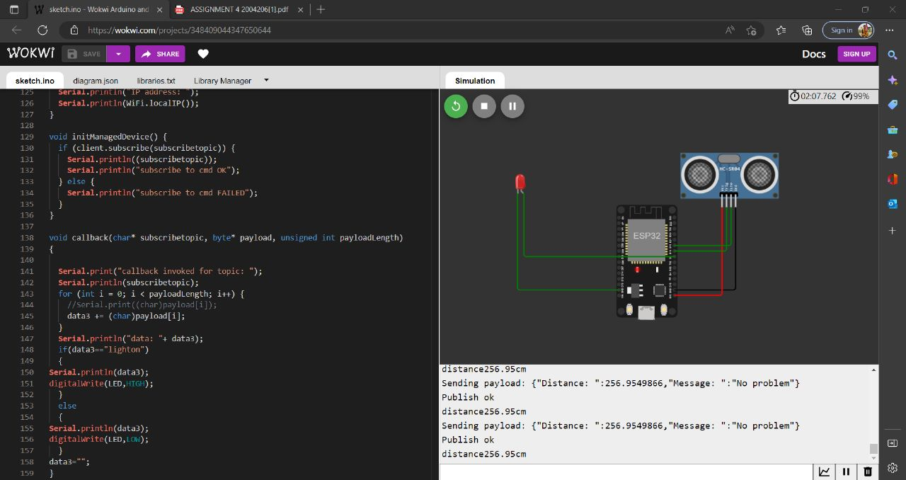

**OUTPUT IN WATSON:**

